Operation Manual for
"PILOT FP" CONTROLLER, VER. 1.0

16.02.2021
The controller is supplied with 12 V from the tractor system. Connect the feeder cable supplied with the controller directly to the battery terminal.

- CONTROLLER ON/OFF
Activate/deactivate the controller by pressing the button shown in Fig. 1.
The device number is displayed first and once the power button is released, the MAIN MENU screen is displayed, as shown in Figure 2.

SETTING THE BUZZER SOUND LEVEL
There are four buzzer sound levels available. In order to set it, press and hold the  button
and then using the 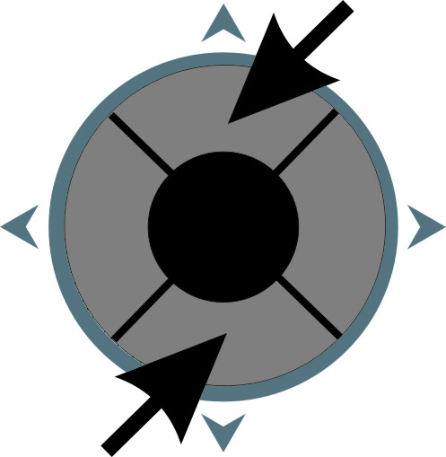 UP/DOWN joystick buttons, set the required buzzer sound level.

SETTING THE DISPLAY BRIGHTNESS

Depending on the outdoor lighting conditions, you can set different values of the display brightness. In order to do so, press and hold the  button. The display brightness starts changing automatically after a while. When the display brightness reaches the convenient level, release the button.
The BUZZER SOUND LEVEL, DISPLAY BRIGHTNESS and CONTRAST are saved after switching off the power supply.

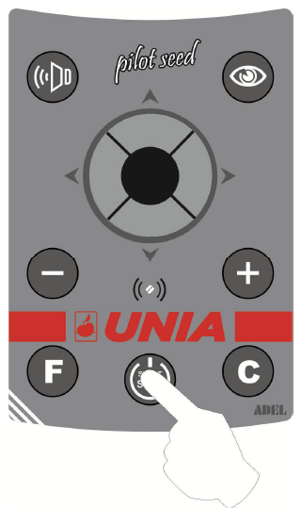
Fig. 1
SETTING THE DISPLAY CONTRAST
In order to change the display contrast, press and hold the button, and then set the right display contrast with the UP/DOWN joystick buttons.
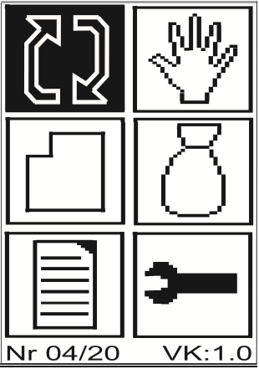
The MAIN MENU window is displayed after the main controller has been switched on. Any of the fields can be selected. The active window is displayed in "negative".

 AUTOMATIC OPERATION
 MANUAL OPERATION
 FIELDS
 SEEDS
 SETTINGS
 SERVICE MENU

In order to select the function of interest, use the joystick arrows to choose the right field (displayed in negative) and press the joystick middle button.
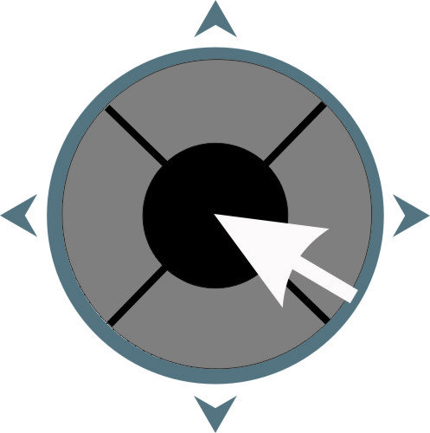

Fig. 2 Main menu
The month and year of the Pilot production are displayed at the bottom of the screen (Fig. 04/20).
Then the Pilot version is displayed (Fig. VK:1.0).
The box that the Pilot is connected to also has its own version. In order to check it, press . For instance, VP: 1.0 is displayed.

2. AUTOMATIC OPERATION

AUTOMATIC OPERATION is used for the correct spreading of the set seed dose.
A sample AUTOMATIC OPERATION MENU window is shown in Fig. 3.

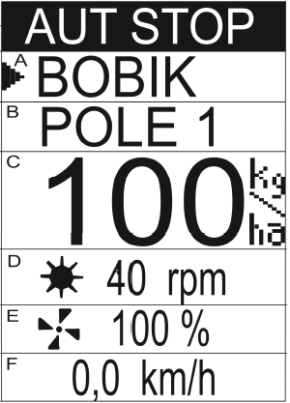

Fig. 3 Automatic operation menu

The window is divided into 6 parts, which are marked with letters A-F in the Figure. The arrow on the left informs which part is the currently selected one. The current working mode is displayed at the top of the screen. In our case, it is the AUTOMATIC STOP mode.

Use the vertical arrows of the joystick  to move the arrow and choose any of the A, B, C or E segments.

DESCRIPTION OF SEGMENTS:

A – SELECTED SEED described only with a name. Detailed information about the seeds is given in the Seed Menu. A Calibration Test and the USED KILOGRAMS counter are assigned to each seed.
In order to change the seed to another one (only when the controller is in the AUTOMATIC STOP mode and the arrow is opposite the seed name), press the middle or right joystick button 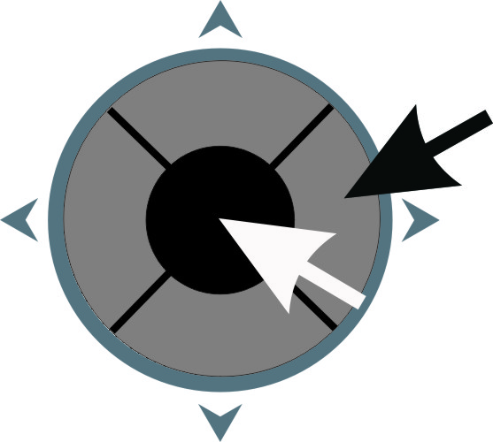. The name of the next of the 10 possible seeds is displayed. Use the Pilot's  or  button to display the approximate WEIGHT of the sown seeds (for the selected seed).

In order to cancel the calculated seed weight, press and hold the .button. The displayed weight starts flashing initially, and then zeroes are displayed, which confirms that the measured value has been deleted.

B – SELECTED FIELD described only with a name. Detailed information about the field is given in the Field Menu. The counter of HECTARES and the WORKING TIME counter are assigned to each field, and the achieved PERFORMANCE is calculated [ha/h].
In order to change the field to another one (only when the controller is in the AUT STOP mode and the arrow is opposite the seed name), press the middle or right joystick button . The name of the next of the 10 possible fields is displayed.
Use the Pilot's or button to display any of the following for the selected field in B: AREA COVERED [hectares.ares], WORKING TIME [hours.minutes] or PERFORMANCE [ha/h]

In order to cancel the area, working time and performance simultaneously, select either of the values in the screen and then press and hold the button. The displayed value starts flashing initially, and then zeroes are displayed, which confirms that the measured values have been deleted.
.

C – SPREAD DOSE The required spread dose is displayed on the screen. It can be set within the 10 kg/ha to 350 kg/ha range.
To change it, press the joystick's right button 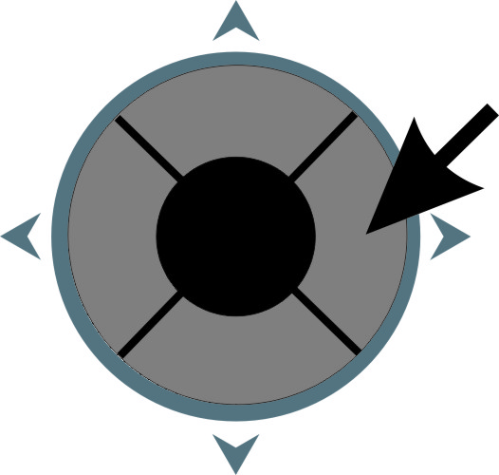. The screen is displayed to enter the numerical value, as shown in Fig. 4.
Use the joystick arrow buttons to select the digit you want to enter above the flashing cursor. The selected digit is displayed in negative. Then press the middle button on the joystick. The selected digit is displayed at the top of the screen. At the same time, the flashing cursor moves one position to the right.
If you make a mistake, you can press on the panel. The cursor moves to the extreme left position, and the display shows only zeroes.

After all digits have been entered, use the arrows to select ENTER and return to the AUTOMATIC OPERATION screen by pressing the middle button on the joystick.
If we want to abandon the previous value change, use the arrows to select ESC and press the middle button on the joystick. You return to the AUTOMATIC OPERATION mode without changing the spread dose.

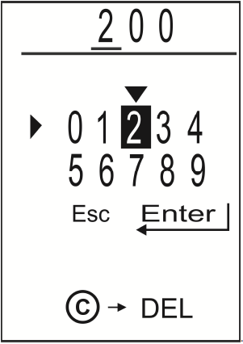

Fig. 4 Entering the numerical value

The dose can also be set with the or on the Pilot. The dose changes incrementally. If you press and hold either of the buttons, the dose changes faster.

If you press and hold the joystick's middle button , automatic sowing of the seeds from the spreader starts. AUT START is displayed at the screen top, and sowing animation is shown in fields D and E (flashing pictograms). The arrow's position on the screen cannot be changed during sowing. The operation is stopped after pressing the joystick middle button.

D – METERING ROLLER

In the AUT STOP status, the displayed metering roller's rpm value is zero.
After sowing is activated (AUT START), the actual rpm of the metering roller is displayed in this field. Adjust the travel speed so that the actual rpm of the metering roller is as close as possible to the rpm in the sowing test. If seed sowing is activated, the roller image is flashing.

E – FAN

This field is used for setting the supply voltage percentage fed to the fan. It affects the fan's rpm. If the fan is activated, the fan pictogram is flashing.
The fan's rpm can be set with or button, with a 5% stroke. The rpm changes incrementally. If you press and hold either of the buttons, the rpm changes faster.

F – TRAVEL SPEED

The TRAVEL SPEED [km/h] is displayed in field F. A vertical bar can appear after an automatic operation is activated (AUT START). It suggests changing the travel speed so that for the set metering dose, the metering roller's rpm is as close as possible to the rpm determined in the sowing test.

For service purposes, simulation of the travel speed might be helpful, despite the spreader being at a standstill. To that end, press and hold the  button and simultaneously press the joystick's middle or right button to activate the operation. A negated value of 10 km/h is displayed in the measurement field. It is a simulated spreader's travel speed. The speed can be changed in the 1 km/h to 25 km/h range, with a 0.5 km/h stroke.
To that end, when the negated value is displayed, press and hold the button and simultaneously use the or button to set the required simulated speed. If you do not switch off the controller, the set speed is saved.
After the controller is switched off and on again, the simulated value of 10 km/h is resumed.
After returning to the AUT STOP mode, the actual speed value is resumed.

A. AUTOMATIC OPERATION ON/OFF

Before activating the AUTOMATIC OPERATION, select DOSE with the arrow on the screen (position it in field C Fig. 3) and then press the middle button on the joystick.
AUT START is displayed in negative at the top of the screen.
The fan is activated first, which is signalled with the fan pictogram flashing. Once the interval is measured, if the seeder position sensor (CP) is in the operating mode and the travel speed exceeds 1 km/h, the metering roller is activated.
It is signalled with the flashing pictogram of the metering roller.
The primary dose can be changed in 10% steps, in the -50% to +50% range. It is done by the joystick's top or bottom button .
Once the primary dose is changed, an image shown below is displayed in the FIELD line ("B" field in Fig. 3). The primary dose value is resumed after switching the automatic operation off and on again.

Fig. 5 Automatic operation

Once you approach a headland, lift the machine, and the seeder position sensor (CP) enters the no-operation position, the metering roller's motor is stopped (the icon in field D stops flashing), but the fan is still working. A flashing drawing, as shown below, is displayed in the current dose field.

Fig. 5a. Stopping the metering roller by the position sensor (CP)

After the spreader is lowered again and the position sensor (CP) set, the roller's turning is activated automatically.
The roller's turning is stopped automatically if the machine is stopped. It is also signalled with a STOP message (see item 8.7). After starting, when the travel speed exceeds 1 km/h, the roller is activated automatically.

Automatic operation is switched off the same way as it is switched on, with the joystick's middle button. The metering roller stops first, followed by the fan.

In the AUTOMATIC OPERATION mode, it is impossible to select what is displayed in fields A and B. It can be done only in the AUT STOP status.

If a message informing about abnormality is displayed in the upper part of the display (DRIVE FASTER, NO SEEDS, etc.), the message can be switched off with the button. If the cause of the message has not been eliminated, the message appears again after the automatic operation is resumed. The list of all possible messages is shown at the end of this Operating Manual.

The weight of the seeds for the particular value of the metering roller's rpm is determined in the sowing test. In order to achieve the required sowing dose, it is best to select the travel speed so that the dose is reached for the same rpm of the metering roller as in the sowing test. If the travel speed is different, a vertical bar with arrows is displayed next to the displayed speed in fields D, E, and F. Its size depends on the difference between the current speed and the speed used for calculations. In order to increase the sowing accuracy, the travel speed should be changed so that the bar disappears.
The DOWN arrows indicate too high travel speed.
The UP arrows indicate too low travel speed.

If for the selected sowing dose and current travel speed, the metering roller's rpm exceeds the linear operation range, a DRIVE FASTER or DRIVE SLOWER message is additionally displayed (see items 8.4 and 8.5).

The and buttons are used for changing the fan's rpm.

3. MANUAL OPERATION

MANUAL OPERATION is used for spreading non-standard fertiliser doses and service works.
A sample MANUAL OPERATION MENU window is shown in Fig. 5.

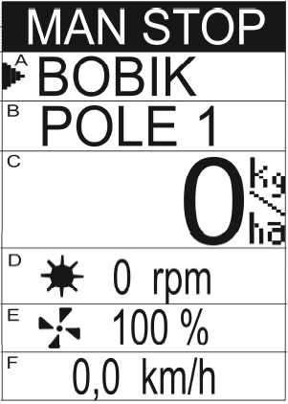

Fig. 6 Manual operation menu

The window is divided into 6 parts, which are marked with letters A-F in the Figure. The arrow on the left informs which part is the currently selected one. The current working mode is displayed at the top of the screen. In our case, it is the MANUAL STOP mode.

Use the vertical arrows of the joystick to move the arrow and choose any of the A, B, C or E segments.

DESCRIPTION OF SEGMENTS:

A – SELECTED SEED described only with a name. Detailed information about the seeds is given in the Seed Menu. A SOWING TEST and the USED KILOGRAMS counter are assigned to each seed.
In order to change the seed to another one (only when the controller is in the MAN STOP mode and the arrow is opposite the seed name), press the middle or right joystick button . The name of the next of the 10 possible seeds is displayed.
Use the Pilot's or button to display the approximate weight of the sown seeds (for the selected seed).
The weight is calculated based on the sowing test result, which indicates the weight of the sown seeds at the specified metering roller rpm. Since the set revolutions of the metering roller can vary from those in the sowing test, especially during manual operation, the calculated seed kilograms may vary from the actual value.

In order to cancel the calculated seed weight, press and hold the button. The displayed weight starts flashing initially, and then zeroes are displayed, which confirms that the measured value has been deleted.

B – SELECTED FIELD described only with a name. Detailed information about the field is given in the Field Menu. The counter of HECTARES and the WORKING TIME counter are assigned to each field, and the achieved PERFORMANCE is calculated [ha/h].
In order to change the field to another one (only when the controller is in the MAN STOP mode and the arrow is opposite the seed name), press the middle or right joystick button . The name of the next of the 10 possible fields is displayed.
Use the Pilot's or button to display any of the following for the selected field in B: AREA COVERED [hectares.ares], WORKING TIME [hours.minutes] or PERFORMANCE [ha/h]

In order to cancel the area, working time and performance simultaneously, select either of the values in the screen and then press and hold the button. The displayed value starts flashing initially, and then zeroes are displayed, which confirms that the measured values have been deleted.

C – SPREAD DOSE The current dose is displayed on the screen.

If you press and hold the joystick's middle button , manual sowing of the seeds starts.
Based on the SOWING TEST for the selected seed, METERING ROLLER'S RPM, the WORKING WIDTH and SPEED, the temporary DOSE is calculated and displayed in this field.

The operation is stopped after pressing the joystick middle button.

D – METERING ROLLER

The metering roller's rpm can be seen in this field. If the metring roller's turning is activated, the roller image is flashing.

E – FAN

This field is used for setting the supply voltage percentage fed to the fan. It affects the fan's rpm. If the fan is activated, the fan pictogram is flashing.
The fan's rpm can be set with or button, with a 5% stroke. The rpm changes incrementally. If you press and hold either of the buttons, the rpm changes faster.

F – TRAVEL SPEED

The TRAVEL SPEED [km/h] is always displayed in field F.

For service purposes, simulation of the travel speed might be helpful, despite the spreader being at a standstill. To that end, press and hold the button and simultaneously press the joystick's middle or right button to activate the operation. A negated value of 10 km/h is displayed in the measurement field. It is a simulated spreader's travel speed. The speed can be changed in the 1 km/h to 25 km/h range, with a 0.5 km/h stroke.
To that end, when the negated value is displayed, press and hold the button. The displayed speed value starts flashing. Press and hold the button, and simultaneously use the or button to set the required simulated speed. If you do not switch off the controller, the set speed is saved.
After the controller is switched off and on again, the simulated value of 10 km/h is resumed.
After the Manual Operation is switched off with the joystick's middle button, the actual speed value is resumed.

3A. MANUAL OPERATION ON/OFF

Before activating the MANUAL OPERATION, select DOSE with the arrow on the screen (position it in field C Fig. 6) and then press the middle button on the joystick.
MAN START is displayed in negative at the top of the screen.
The fan motor is activated first, signalled with the fan pictogram flashing on the controller screen. Once the interval is measured (described in item 6.4), the metering roller motor is activated if the seeder position sensor (CP) is in the operating mode. It is signalled with the flashing pictogram of the metering roller on the controller screen.
The dose can be changed by increasing/decreasing the metering roller's rpm. It is done by the joystick's top or bottom button .
Once the metering roller is controlled, the drawing as the one below is displayed in the FIELD line ("B" field in Fig. 7).
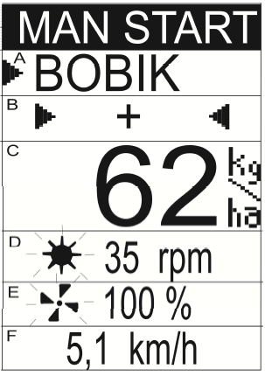

Fig. 7 Manual operation

The and buttons are used for changing the fan motor speed.

Once you approach a headland, lift the machine, and the seeder position sensor (CP) enters the no-operation position, the metering roller's motor is stopped (the icon in field D stops flashing), but the fan is still working.
After the spreader is lowered again and the position sensor (CP) set, the roller's rpm is activated automatically.

Manual Operation is switched off the same way as it is switched on, with the joystick's middle button. The metering roller stops first, followed by the fan.

Neither the seeds presence nor the travel speed is checked during Manual Operation. Only the supply voltage and no short-circuit in the control valve are checked. If either of the abnormalities occurs, a message is displayed on the Pilot's screen.

4. FIELDS

There are 10 fields available for the user, where the hectares covered, operation time and efficiency are calculated independently. The user can assign any 7-character name to each of the fields.
Figure 7 shows a sample view of the FIELD menu.

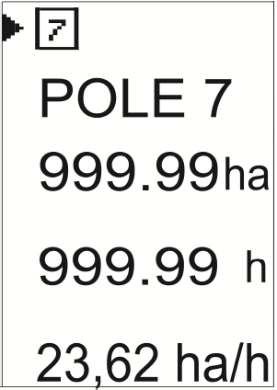

Fig. 8 Field menu
4.1 FIELD SELECTION

In order to select any of the 10 fields for which the hectares and the operation time are calculated, use the upper button of the joystick 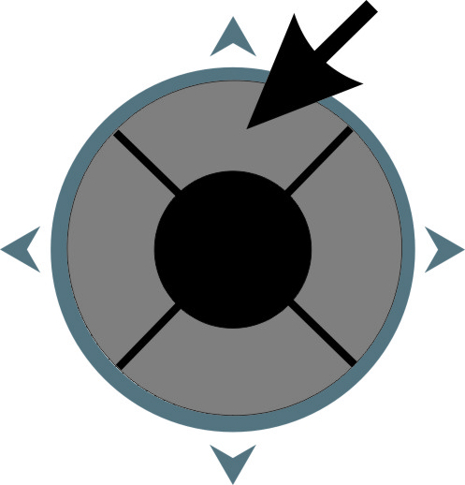 to position the arrow near the square with the currently selected field number, and then press the middle or right button of the joystick until the correct field number is displayed.

4.2 NAMING A FIELD

The user can assign a 7-character name to any of the 10 fields. The name should be easy to remember as it is used when selecting the field in the automatic and manual operation. Similarly to the field selection, first position the arrow near the previous name of the field, and then press the middle or right button on the joystick. A screen is displayed, as shown in Fig. 9.

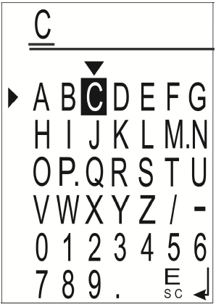

Fig. 9 Editing the name

Use the joystick arrow buttons to select the character you want to enter above the flashing cursor. The selected character is displayed in negative. Then press the middle button on the joystick. The selected character is displayed at the top of the screen. At the same time, the flashing cursor moves one position to the right.
If you make a mistake, you can press on the panel. The cursor moves one position to the left, deleting the last character entered.

After the full name has been entered, use the arrows to select ENTER (bottom right) and return to the FIELDS screen by pressing the middle button on the joystick.

If you don't want to change the previous number of the field, select ESC (the last but one character at the bottom) and press the middle button on the joystick.

4.3 CANCELLING THE FIELD

A resettable counter of hectares and the operation time counter is assigned to each of the 10 fields.

HECTARES are calculated from 1 are to 999,999 ha. Hectares and ares are displayed first. Then, when the counter value increases, only hectares are displayed.

The OPERATION TIME is counted from 1 minute to 99,999 h. Hours and minutes are displayed first. Then, when the counter value increases, the dot disappears, and only hours are displayed.

In order to cancel the counter assigned to the selected field, position the arrow in front of the hectare counter using the joystick and then press and hold the middle or right button on the joystick.
. You can also press and hold the button.
The digits are flashing initially, and then zeroes are displayed.

The value of the non-resettable counter of the hectares covered is displayed in the SERVICE MENU.

5. SEEDS

The user can save 10 seeds for which the poured kilograms are counted independently. The user can assign any 8-character name for each seed type, specify its bulk weight and the metering roller's rpm for which the test was carried out. The bulk weight is the weight of the seeds released from the spreader in 1 minute of the metering roller's turning.
Figure 10 shows a sample view of the SEEDS menu.

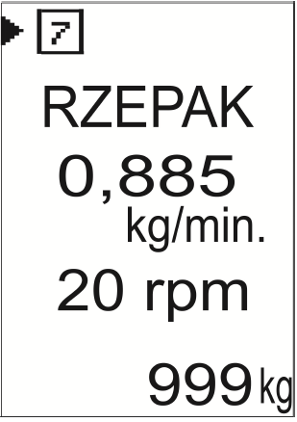

Fig. 10 Seeds menu
5.1 SELECTING THE SEEDS

In order to select any of the 10 seeds for which the kilograms are calculated and whose seeding test result is used to calculate the seed dose, use the upper button of the joystick to position the arrow near the square with the currently selected seed number and then press the middle or right button of the joystick until the correct seed number is displayed.

5.2 CHANGING THE SEED NAME

The user can assign a 7-character name to any of the 10 seeds. The name should be easy to remember as it is used when selecting the seeds in the automatic and manual operation. First, position the arrow near the previous name of the seeds, and then press the middle or right button on the joystick. A screen is displayed, as shown in Fig. 11.

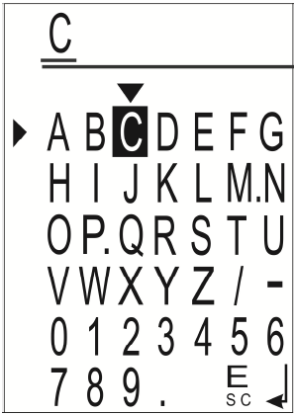
Fig. 11 Editing the name

Use the joystick up/down buttons to select the character you want to enter above the flashing cursor. The selected character is displayed in negative. Then press the middle button on the joystick. The selected character is displayed at the top of the screen. At the same time, the flashing cursor moves one position to the right.
If you make a mistake, you can press on the panel. The cursor moves one position to the left, deleting the last character entered.

After the full name has been entered, use the arrows to select ENTER (bottom right) and return to the SEEDS screen by pressing the middle button on the joystick.

If you don't want to change the previous name of the seeds, select ESC (the last but one character at the bottom) and press the middle button on the joystick.

5.3 ENTERING THE SEED SOWING TEST RESULT

Each of the 10 seed types is assigned its bulk weight, which means the weight of the seeds released by the metering roller in 1 minute at the specific rpm of the metering roller. Several standard sowing test results are saved in each brand new controller.
If you know the bulk weight of the seeds and want to enter its value manually, position the display arrow opposite the previous sowing test value, using the joystick's top or bottom button. Then press the middle or right button on the joystick . The screen is displayed to enter the numerical values, as shown in Fig. 12.
Use the joystick arrow buttons to select the digit you want to enter above the flashing cursor. The selected digit is displayed in negative. Then press the middle button on the joystick. The selected digit is displayed at the top of the screen. At the same time, the flashing cursor moves one position to the right.
If you make a mistake, you can press on the panel. The cursor moves to the extreme left position, and the display shows only zeroes.
After all digits have been entered, use the arrows to select ENTER and return to the SEEDS screen by pressing the middle button on the joystick.
If we want to abandon the previous value change, use the arrows to select ESC and press the middle button on the joystick. You come back to the SEEDS screen without changing the sowing test weight.
The value of the metering roller's rpm for which the sowing test was performed is entered in the same way.

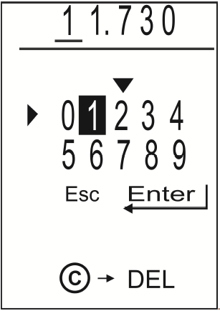
Fig. 12. Entering the sowing test weight

5.4 CANCELLING THE KILOGRAMS USED

A resettable counter of kilograms used is assigned to each of the 10 seed types.

KILOGRAMS are counted up to the value of 9,999,999 kg.

In order to cancel the counter assigned to the selected seed, position the arrow in front of the kilogram counter using the joystick and then press and hold the middle or right button on the joystick.
. You can also press and hold the Pilot's button.
The digits are flashing initially, and then zeroes are displayed.

The value of the non-resettable counter of kilograms is displayed in the SERVICE MENU.

6. SETTINGS

This menu is used for entering the physical parameters of the spreader. They include:

- WHEEL CIRCUMFERENCE
- NUMBER OF WHEEL PULSES
- SPREADER'S WORKING WIDTH
- DELAY BETWEEN THE FAN AND METERING ROLLER OPERATION START/STOP
- NUMBER OF PULSES PER ONE REVOLUTION OF THE METERING ROLLER
- OPERATING MODE OF THE POSITION SENSOR (CP)

To change any of the settings, use the joystick's up and down buttons to position the arrow opposite the value to be changed, and then press the joystick's middle or right button. .
Leave any of the settings, apart from the OPERATING MODE OF THE POSITION SENSOR (CP), by pressing the joystick's left button.

6.1 SETTING THE WHEEL CIRCUMFERENCE

If you use a GPS device for speed measurement, then the pulse number/ 1 m is given. In such a case, you can enter the WHEEL CIRCUMFERENCE of 1 m and the number of pulses/ 1 m when entering the NUMBER OF WHEEL PULSES.

The users of tractors with a 7-pin DIN/ISO seat can enter the number of the wheel pulses, e.g. 100, and then the wheel circumference calibration described in item 7.2 can be performed and the new calculated wheel circumference saved.

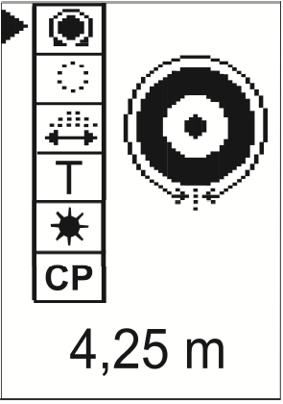

Fig. 13 Setting the wheel circumference
Wheel-mounted sensor
If you know the wheel circumference, you can enter it manually. You can also calibrate the wheel circumference by covering the suggested distance of 100 m.

In order to manually enter the wheel circumference and other values, press the middle or the right button on the joystick . The screen is displayed to enter the numerical values, as shown in Fig. 14.
Use the joystick arrow buttons to select the digit you want to enter above the flashing cursor. The selected digit is displayed in negative. Then press the middle button on the joystick. The selected digit is displayed at the top of the screen. At the same time, the flashing cursor moves one position to the right.
If you make a mistake, you can press on the panel. The cursor moves to the extreme left position, and the display shows only zeroes.
After all digits have been entered, use the arrows to select ENTER and return to the SETTINGS screen by pressing the middle button on the joystick.
If we want to abandon the previous value change, use the arrows to select ESC and press the middle button on the joystick. You come back to the SETTINGS screen without changing the previous value.

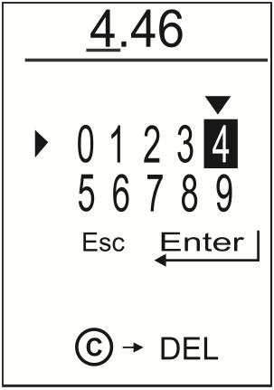
Fig. 14 Entering the wheel circumference
6.2 SETTING THE WHEEL PULSES

The wheel pulses can be set between 1 and 250. A new value is entered in the same way as the wheel circumference.
High values are intended for GPS devices indicating the speed as IMP/1M and for users of tractors with DIN/ISO seats.

Fig. 15 Setting the wheel pulses

6.3 SETTING THE WORKING WIDTH

The working width can be set between 1.0 and 12.0 m. A new value is entered in the same way as the wheel circumference.

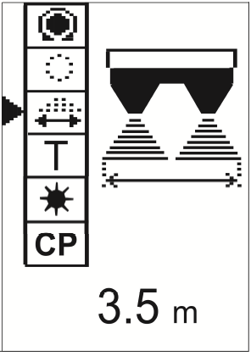

Fig. 16 Setting the working width

6.4 SETTING THE DELAY BETWEEN THE FAN AND THE ROLLER' OPERATION START (STOP)

When the spreader operation is activated, first the fan starts to operate, followed by the metering roller. The same applies to deactivation - first, the metering roller stops and then the fan follows. Here you can set the delay between the fan and the metering roller operation start/stop. The delay can range from 2 to 9 seconds. A new value is entered in the same way as the wheel circumference.

Fig. 17 Setting the delay between the fan and the metering roller operation start/ stop.

6.5 SETTING THE NUMBER OF THE METERING ROLLER PULSES

The value is entered by the manufacturer and should not be changed by the user.

In order to enter the procedure, first press and hold the button and simultaneously press the joystick's right or middle button.

The number of pulses can be set within the range from 1 to 99. A new value is entered in the same way as the wheel circumference.

Fig. 18 Setting the number of the metering roller pulses
6.6 OPERATING MODE OF THE POSITION SENSOR (CP)

Select if the spreader is supposed to operate when the position sensor (CP) is active or not active.
In order to change the current value to an opposite one, first press and hold the button and simultaneously press the joystick's right or middle button.
A drawing with a changed position sensor's (CP) operating mode is displayed after a while.

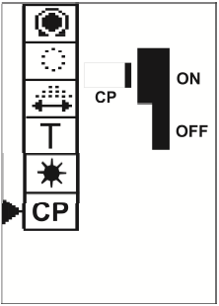 Fig. 19 Operation with the position sensor (CP) activated

If metal approaches the face of the position sensor (CP), the metering roller's turning is activated in the AUTOMATIC or MANUAL OPERATION mode.

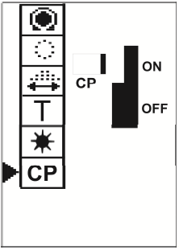 Fig. 20 Operation with the position sensor (CP) deactivated

If metal moves away from the face of the position sensor (CP), the metering roller's turning is activated in the AUTOMATIC or MANUAL OPERATION mode.
7. SERVICE MENU

This menu displays the statuses of induction sensors, the status of the non-resettable counters of the hectares covered and the used seed kilograms. The wheel circumference calibration, sowing test and tank emptying procedures are also available.

Figure 21 shows a sample view of the menu.

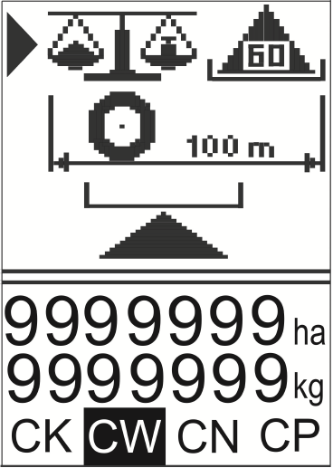

Fig. 21 Service Menu

The statuses of induction sensors are displayed at the bottom:
CK – WHEEL SENSOR
CW – METERING ROLLER SENSOR
CN – SENSOR OF THE SEEDS PRESENCE IN THE HOPPER
CP – SPREADER POSITION SENSOR
The status of the non-resettable counters of total hectares covered during sowing and the used seed kilograms are displayed above.
Further on, you can enter the tank emptying and wheel calibration procedures, with the seed sowing test procedure at the top.

7.1 SOWING TEST

The procedure is meant to determine the fertiliser weight released from the spreader in 60 seconds of the metering seed turning at the set rpm.

In order to move from the SERVICE MENU to the sowing test, select the sowing test image on the screen with the right arrow (as in Fig. 21) and press the middle or right button on the joystick . A drawing is displayed on the screen - see the example in Fig. 22.

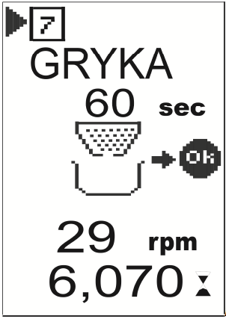Fig. 22 Sowing test

The arrow at the top of the screen shows the seed number and the seed name (below) for which the sowing test is performed. To select other seeds, press the joystick's middle or right button. The seed names are displayed one after another.

The metering roller's rpm in the sowing test are displayed below. For example, in Figure 22, the value is 29 rpm.
The current sowing test result is displayed at the bottom (seed weight in kg).
If you want to change the metering roller's rpm in a new sowing test, position the arrow opposite the METERING ROLLER'S RPM and press the joystick's middle or right button . The screen is displayed to enter the numerical values, as shown in Fig. 23. Proceed as previously.
Use the joystick arrow buttons to select the digit you want to enter above the flashing cursor. The selected digit is displayed in negative. Then press the middle button on the joystick. The selected digit is displayed at the top of the screen. At the same time, the flashing cursor moves one position to the right.
If you make a mistake, you can press  on the panel. The cursor moves to the extreme left position, and the display shows only zeroes.
After all digits have been entered, use the arrows to select ENTER and return to the CALIBRATION TEST screen by pressing the middle button on the joystick.
If we want to abandon the previous value change, use the arrows to select ESC and press the middle button on the joystick. The previous value is not changed.

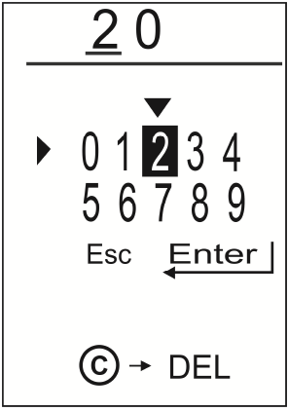

Fig. 23 Entering the metering roller's rpm in a sowing test.

A vessel of a known weight and scales are necessary for a sowing test. Pour the seeds whose bulk weight you want to specify into the spreader hopper.
The seed level sensor's (CN) indication is not taken into account. Place the vessel under the spreader outlet. The blower is on during the sowing test.
Position the arrow on the spreader image and press the joystick's right or middle button . The metering roller starts operating at the pre-set speed. The second counter starts counting the 60 seconds. The status of the metering roller's sensor (CW) is displayed in the top right corner of the screen.
If you press the joystick's left button 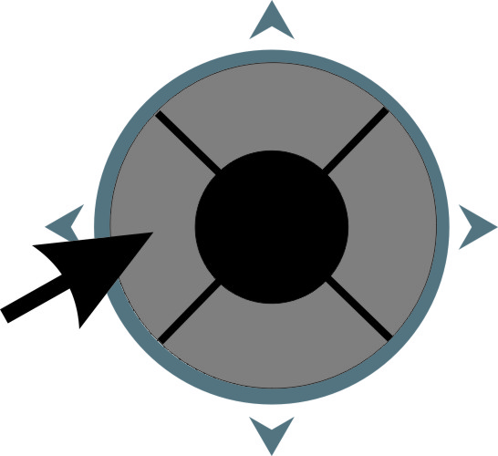 during the sowing test, the metering roller stops, the original value of the measured time is resumed, and you can start the sowing test again.

Since it takes a few seconds to set the metering roller's correct rpm, in order to improve the sowing test accuracy, you can stop the test by pressing the joystick's left button when the metering roller reaches the correct rpm. Then empty the vessel with the seeds and press the joystick's middle button to re-start the sowing test. The metering roller starts operating at the correct speed.

After 60 seconds, the metering roller's motor stops and the controller automatically switches to the numerical value entering menu. Weight the seeds and enter the value. After positioning the cursor on the ENTER field, you come back to the main Sowing Test. The new value of the bulk weight is displayed at the bottom of the screen; the value is assigned to the selected seed together with the set metering roller's rpm.

7.2 WHEEL CIRCUMFERENCE CALIBRATION

The calibration is carried out for the speed measurement induction sensor. You can determine the wheel's virtual circumference if you use the DIN/ISO seat in the tractor.
If you use a GPS device, enter the values quoted by the manufacturer.

The accuracy of the fertiliser spreading, travel speed measurement, and the area covered depends on the precise determination of the wheel circumference. The presented supporting procedure for the wheel circumference calibration facilitates the measurements in real conditions. Before starting the calibration, fill half of the spreader tank with seeds and prepare a ca. 100 m long tape measure. Measure the tilled field. Make sure that the number of pulses per one complete revolution of the wheel has been entered correctly.

In order to move from the SERVICE MENU to the wheel circumference calibration, select the wheel circumference calibration image on the screen with the arrow (middle arrow as in Fig. 21) and press the middle or right button on the joystick. A drawing is displayed on the screen - see the example in Fig. 24.

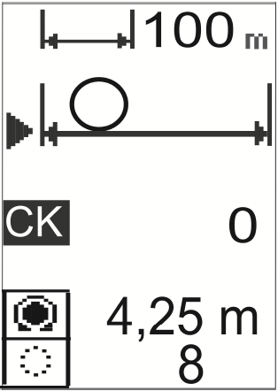
Fig. 24 Wheel circumference calibration

The proposed distance of the run (100 m) is displayed at the top of the drawing. If you want to change it, position the arrow at the distance, and press the middle or the right button on the joystick . The screen is displayed to enter the numerical values, as shown in Fig. 25. Next, enter the desired distance of the run. Finally, use the arrows to select ENTER and return to the WHEEL CIRCUMFERENCE CALIBRATION screen by pressing the middle button on the joystick.

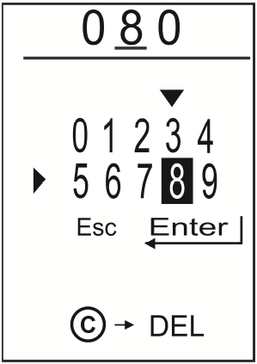
Fig. 25 Entering the distance of the run at the wheel circumference calibration

In order to start the calibration, park the tractor at the beginning of the measured section of the way. Mark the point by hammering a stake into the ground. Then press the right or the middle button on the joystick and start driving the tractor along the measured section. The run animation is displayed on the screen. After each pulse from the wheel sensor (CK), the counter value increases by 1. After covering the whole section, stop and press again the middle or right button on the joystick . A new wheel circumference is displayed at the bottom of the screen. It automatically replaces the previous one.
The button deletes the pulse counter content. You don't have to use it because if the wheel circumference calibration is stopped and you want to repeat it, the pulse counter is reset automatically.
Use the joystick's left button to return to the SERVICE MENU.

7.3 TANK EMPTYING

In order to move from the SERVICE MENU to the tank emptying procedure, tan emptying pictogram on the screen with the arrow (bottom arrow as in Fig. 21) and press the middle or right button on the joystick . A drawing is displayed on the screen - see the example in Fig. 26.

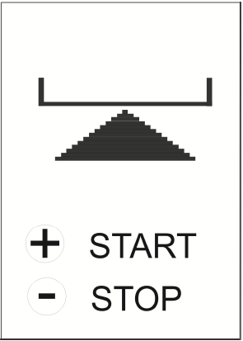

Fig. 26 Tank emptying

Press the button to start sowing the seeds from the metering unit at maximum speed. The fan is not working.
Press the button to stop sowing the seeds from the metering unit.

Use the joystick's left button to return to the SERVICE MENU.

8. EMERGENCIES

The messages informing about emergencies are displayed in AUTOMATIC OPERATION and sometimes in the MANUAL OPERATION.

COMMON MESSAGES

8.1 SUPPLY VOLTAGE TOO LOW

Check the condition of the battery and the battery charging system in the tractor. Also, check the quality of the controller feeder cables and the quality of the electric connection on the battery terminals.

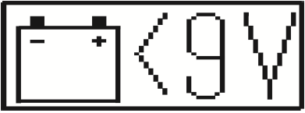

8.2 SUPPLY VOLTAGE TOO HIGH

The voltage controller in the tractor can be damaged. Switch off the controller as quickly as possible and remove the controller supplying plug.

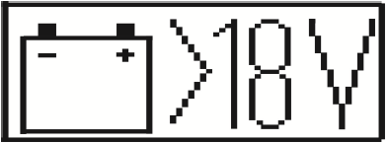

8.3 SHORT-CIRCUIT IN THE METERING ROLLER'S MOTOR CIRCUIT

Too high current consumption by the metering roller's motor. The controller starts sampling, feeding the supply voltage for a short time, and checks if the short-circuit is maintained all the time. If so, remove the connection block from the roller's motor. If the message disappears, check the roller's motor. If the message does not disappear, replace the cable connecting the roller's motor with the controller.
If you remove the clamp from the S5 sensor, the metering roller's short-circuit protection system is deactivated.

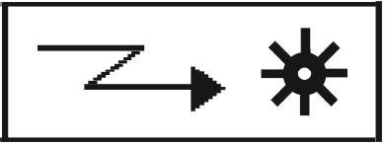

8.4 TOO HIGH CURRENT CONSUMPTION BY THE METERING ROLLER'S MOTOR

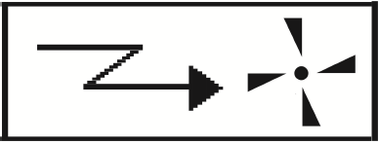

The controller starts sampling, feeding the supply voltage to the fan motor for a short time, and checks if too high current consumption (over 35 A) is maintained all the time.
Make sure the fan is not blocked or the supply lines are not damaged.

If you remove the clamp from the S6 sensor, the fan motor's short-circuit protection system is deactivated.

MESSAGES AVAILABLE ONLY IN THE AUTOMATIC OPERATION MODE

8.5 DRIVE FASTER

In order to achieve the required automatic dose, the metering roller's rpm has to be below the control range. Drive faster.



8.6 DRIVE SLOWER

In order to achieve the required automatic dose, the metering roller's rpm has to be above the control range. Drive slower.

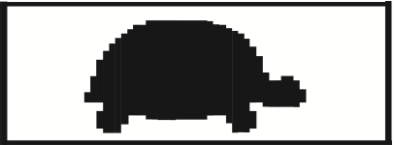

8.7 NO SEEDS

The sensor in the spreader hopper detected a lack of seeds

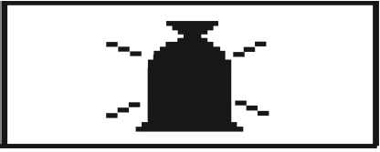

8.8 NO PULSES FROM THE WHEEL

Seed sowing is stopped automatically. When the pulses from the wheel sensors are resupplied, sowing is automatically resumed.

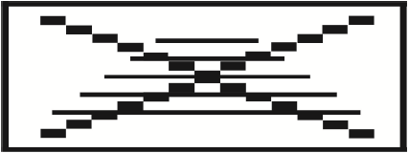

The messages available in the AUTOMATIC OPERATION mode can be temporarily deactivated. If any of the messages occurs, press the button. If the cause of the message has not been eliminated, the message appears again after the automatic operation is resumed.

